Come and join us for arts, crafts, coffee and a chat!!

Introducing Printmaking
Friday, 6th Sept, 10.30am – 12.30pm
CHANCE, 2, Rickaby Street, East End, Sunderland SR1 2DL

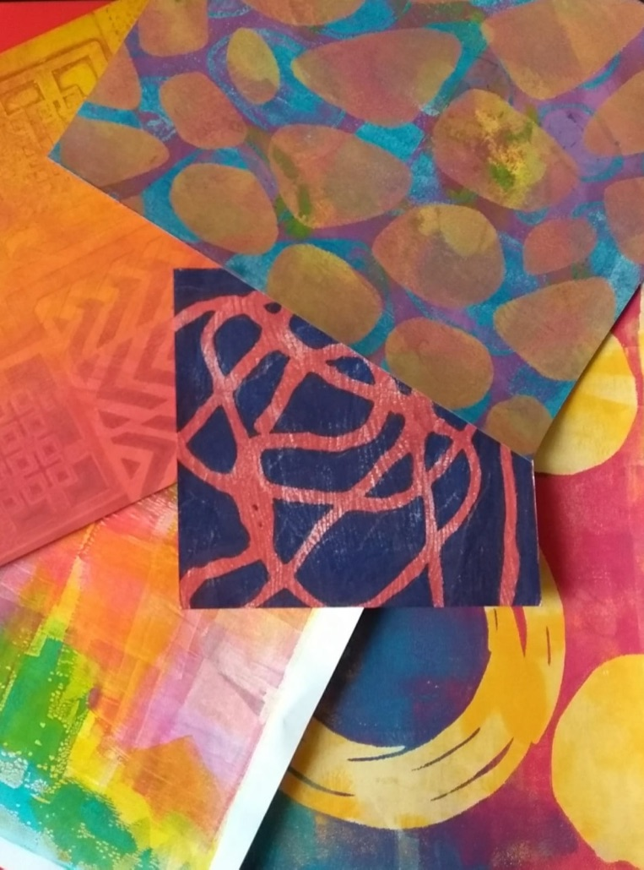
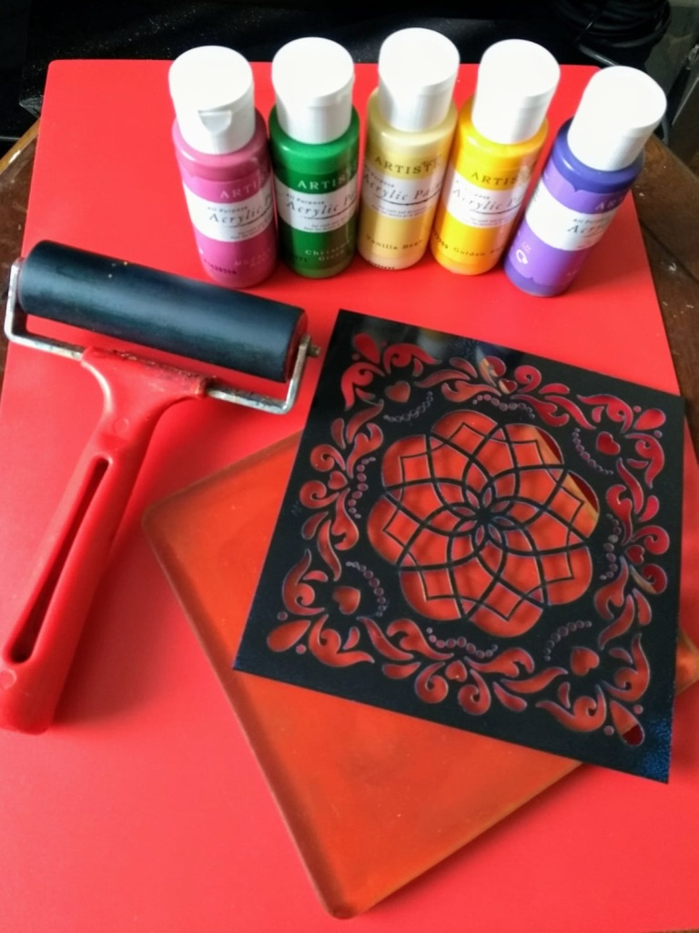

Printmaking Course - Led by Denise Lovell, the course runs over six weeks and no previous experience or artistic skill is needed. Even complete beginners can create amazing prints. Using a variety of materials, such as gel plates, stencils, texture tools and paints you will explore a world of design, patterns and creative ideas. So, don’t miss it.

Fee: £3 per session charged towards coffee and materials.

Sunderland Women’s Art Group (SWAG) is a friendly women’s group that meets every Friday at CHANCE, Sunderland helping women to feel positive about themselves through creative activities.

For more information about the art workshops, contact Padma Rao – 07885982436
For information about The Well Project – Nina Sumby – 07837639081 or email: projectsangini@gmail.com

The SWAG art workshops and courses are part of The Well project, supported by the COUNTY DURHAM COMMUNITY FOUNDATION from the Tampon Tax Community Fund, The Community Foundation, the Foyle Foundation and Awards for All.

